(Title) Ligatures Summer School:

(Subtitle) Extended abstract template and instructions
Keywords: Up to a maximum of 5 words, separated by commas
The purpose of this template is to provide a general-purpose structure for authors. It aims to focus on the relevant aspects of each author’s work to provide a better reading comprehension for the scientific and technical review committee. It should be considered as a set of guidelines.
The proposal must be submitted on the Microsoft CMT platform (https://cmt3.research.microsoft.com/LIGA2025/) by the deadline (12 June). The program chair(s) will first verify the proposal's relevance and ensure the submission requirements are fulfilled. And then assign it to a double-blind peer review by the review committee.
Please anonymize the authors’ information in the document. The body of the abstract text must not contain any elements that identify its authors. If needed, please mention [reference omitted for review].
The length of the body of the abstract text must be between 600 and 750 words. Authors must include the main bibliographical references used in the abstract in an additional section (not counted towards the word limit). If needed, authors may organize the abstract in sections and subsections.
Authors must include 3 to 5 images or graphics properly referenced and annotated, illustrating their research or applications.
Please use this document as the base style template:
- Proposal title: Title paragraph style (Times, 16pt, 1.15 line spacing);
- Section titles: Heading 1 paragraph style (Times, 14pt, 1.15 line spacing);
- Subsection titles: Heading 2 paragraph style (Times, 12pt, 1.15 line spacing);
- Captions: Caption paragraph style (Times Italic, 8pt, 1.15 line spacing);
- Text body: Normal paragraph style (Times, 10pt, 1.15 line spacing);
- Keywords: Normal + Italic paragraph style (Times italic, 10pt, 1.15 line spacing);
- Footnotes: Footnote Text paragraph style (Times italic, 8pt, 1.15 line spacing);
For more information, see the conference website: https://ligatures.fba.up.pt/
The structure and nature of the text are the responsibility of each author. We recommend using a familiar IMRaD structure for this kind of work, addressing topics such as: Goals and Objectives, Problematic or Theoretical Framework, State of the Art or Literature Review, Research Methodology, Discussion and Results, and clarifying the main contributions of this submission to the Summer School, or the Academic Community.

Goals and Objectives
The authors should start the abstract text by stating the purpose of the work or research clearly and explicitly. If possible, authors should provide details on the scope or the context of application of the work or research, among other data, to provide a better understanding of the work process or results.

Problem
Authors should then clarify the problem through the enunciation of the research question(s) and hypotheses, or the propositions that structure the design of the research project. The identification of the main theoretical or operational concepts should follow, including a brief theoretical background, identifying the authors, works, or any relevant literature. Or to include another form of identification, or state of the art review of the thematic area.

Methodology
Regardless of being a more theoretical research work, report or a more practical design approach, the authors should identify the type of plan (qualitative, quantitative, mixed, etc.), or the adopted methodology with the methods employed (document analysis, case study, ethnography, grounded theory, action-research, research development, iterative analysis, participatory design workshops, co-design sessions, speculative design, visual storytelling, A/B testing, Digital ethnography, Social media analysis, autoethnography, sensory ethnography, photo/video elicitation, agile/iterative prototyping, algorithmic bias audits, tangible interaction design, machine learning integration, Systematic literature reviews, bibliometric analysis, discourse analysis, digital humanities approaches…), and specific tools (e.g. Figma, Adobe Creative Suite applications, Visual Studio Code, Blender, Tobii Eye-tracking, NVivo or Atlas.ti for qualitative coding, Dedoose for collaborative analysis, Unity/Unreal Engine (3D environments), Processing/p5.js (creative coding), Arduino/Raspberry Pi (physical computing), UserTesting.com for usability studies), and finally any technical standards (use and promotion of code repositories (GitHub/GitLab), File and Document or code formats ….
Explanations should be succinct, nevertheless, at the same time, to provide a reasonable degree of detail necessary to understand what are the factors or variables analyzed in the study, which were the data collection instruments (evaluation frameworks, surveys, interviews, groups focus, etc.), its procedures and the main data and results obtained in applying these instruments.
Please be aware and identify any Ethical Considerations of working with subjects or participants (explicit requirements for informed consent, anonymization of participants, and handling sensitive cultural data), and state any permissions for using third-party tools, or visual assets, including Artificial Intelligence in the process.

Results and Conclusion
The abstract should also provide a critical analysis of the results or the expected results (in the case of an ongoing research or project). In this analysis, it is important to clarify the main difficulties or constraints and to identify the challenges and opportunities for future application (whether results or methodologies), in different contexts, with different audiences, or any other variant of the methodology and variables used in the study.

Contribution
Authors should clearly state how it is that the proposed work provides a relevant contribution to the Summer School, to the proposed thematic area, to adjacent areas of design, typography, or literature and writing studies, or to the academic community in general.

References
References are not counted towards the word limit, and should use the 7th edition of the APA standards for the body text and final bibliographic references section. The APA standards can be reviewed online at: http://www.apastyle.org.

Supplementary Materials (Images, Graphics, Prototypes…)
The “Supplementary Materials” section does not count toward the word limit. It should accommodate images and/or graphics of the process and/or final research or practice-based work, and should be embedded in the .docx file.

Images (figures or graphics) should be referenced within the main text as in the example below (Figure 1). Be careful to scan the images with the right quality for viewing the drawings and their notes. It is recommended to publish images in JPG format, Full HD, or 4K UHD resolution (Ultra High Definition) up to 3840 x 2160 px, at 72 DPI, in RGB mode. Captions should describe the image contents and/or credit their sources.

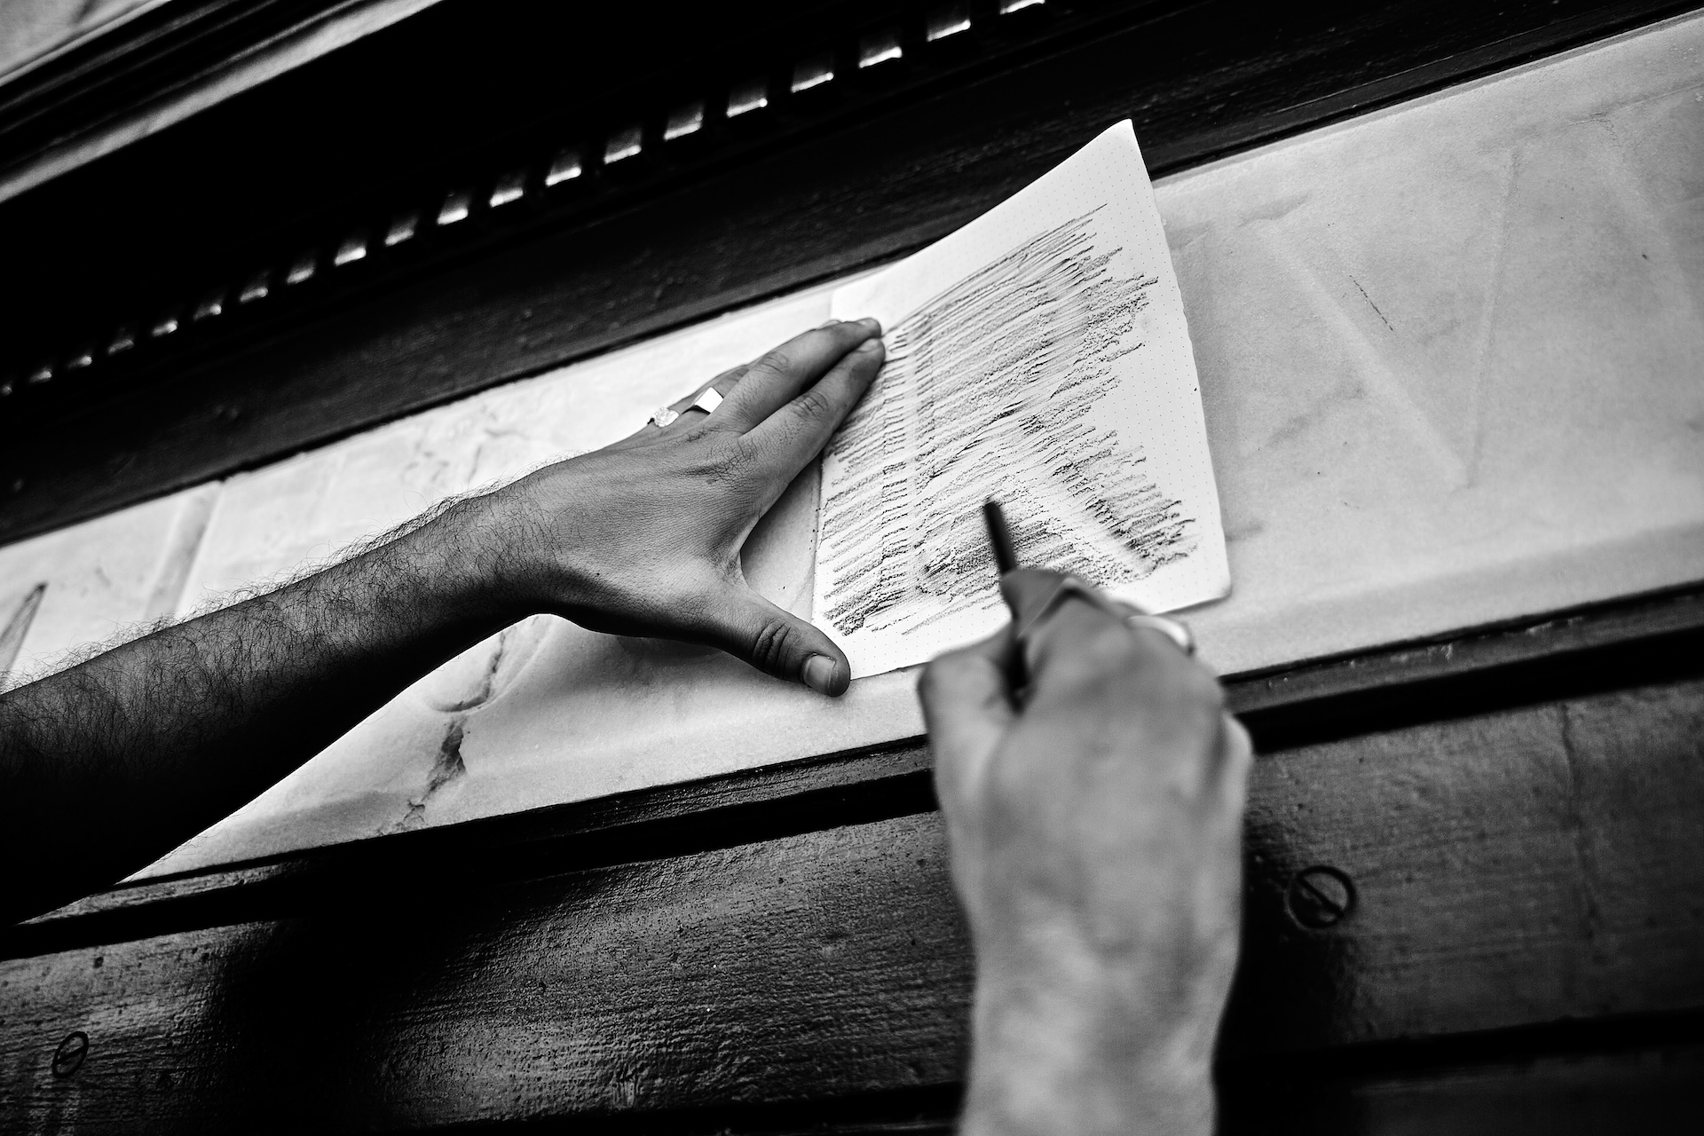
Figure 1 – Caption example of Diogo Rapazote demonstrating how to capture a stone-engraved letter by doing a “guerrilla rubbing” during the 2024 Ligatures Summer School (Photo Credits: Pedro Amado, 2024. Retrieved from https://ligatures.fba.up.pt/2025/rapazote-2024.html)
You may include links to prototypes, video demos, or interactive prototypes, field notes, audio/visual excerpts, GitHub repositories, datasets (with proper anonymization), but there’s no guarantee the reviewers will view them.

We recommend using a reference manager such as Mendeley or Zotero. Available online at: https://www.mendeley.com/download-reference-manager/ or at https://www.zotero.org/ (retrieved on 2025-04-24).

